Terraform task 4
- Install Terraform on your PC
Go to the website https://developer.hashicorp.com/terraform/install
#Steps To Install Terraform on Windows 10 or 8 or 7
1) Download Terraform
https://www.terraform.io/downloads.html
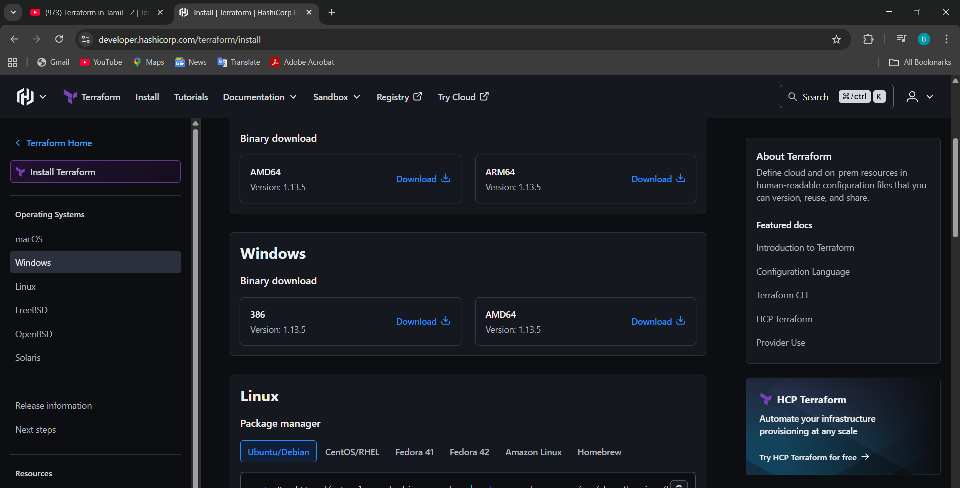
2) Unzip the terraform package
Once download the package and extract the file to the C disk location
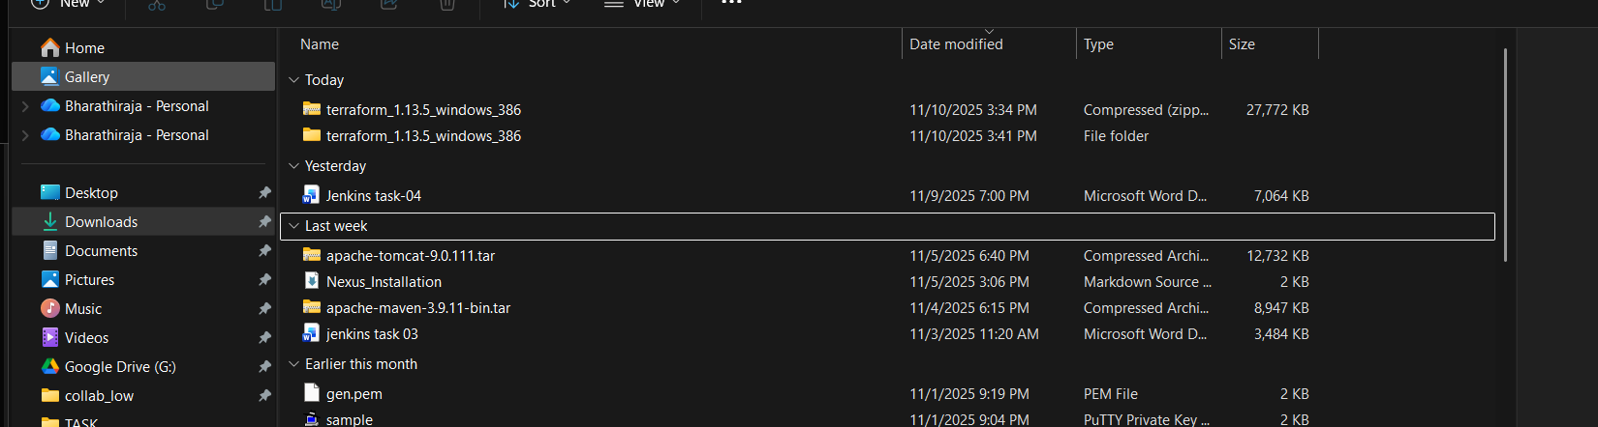
Then, after downloading part, open the git bash open the check the Terraform location 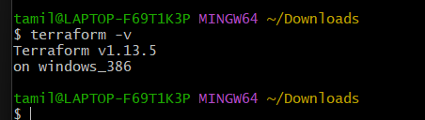
Go to the search part in Windows Search system variables, a window will open, click on that environmental variable
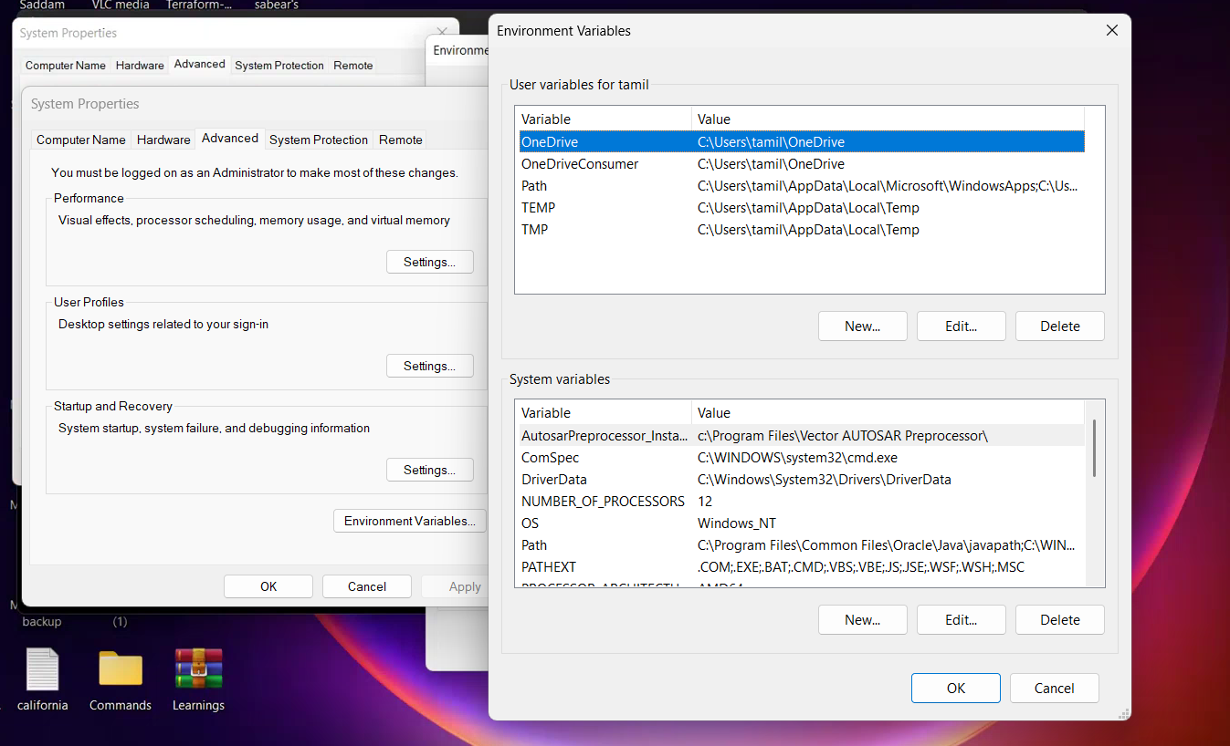

Open a folder like Terraform bharathi name I mentioned
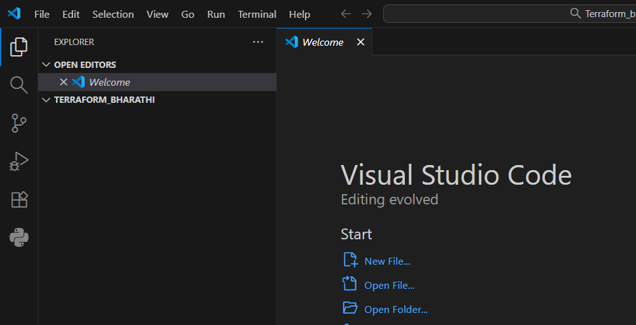
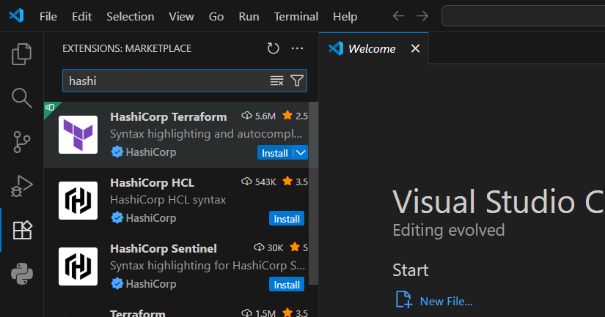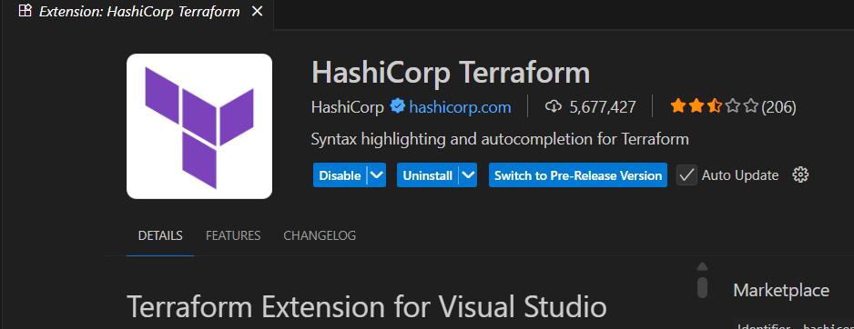
Then, after create a Visual Studio, execute the code
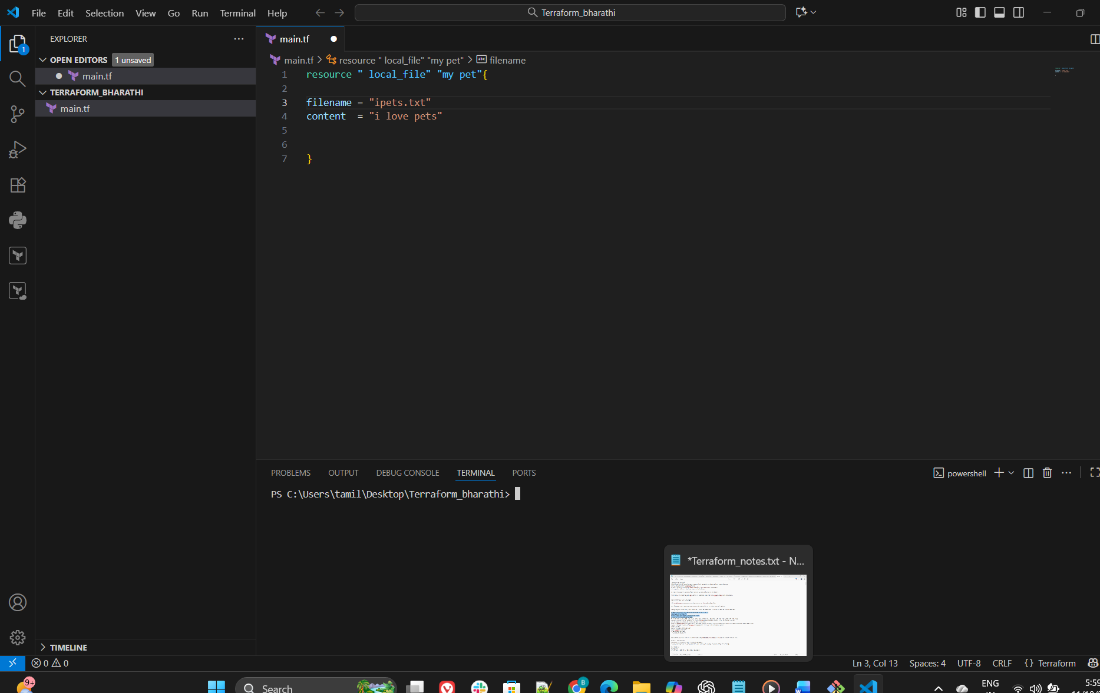
Give ls and
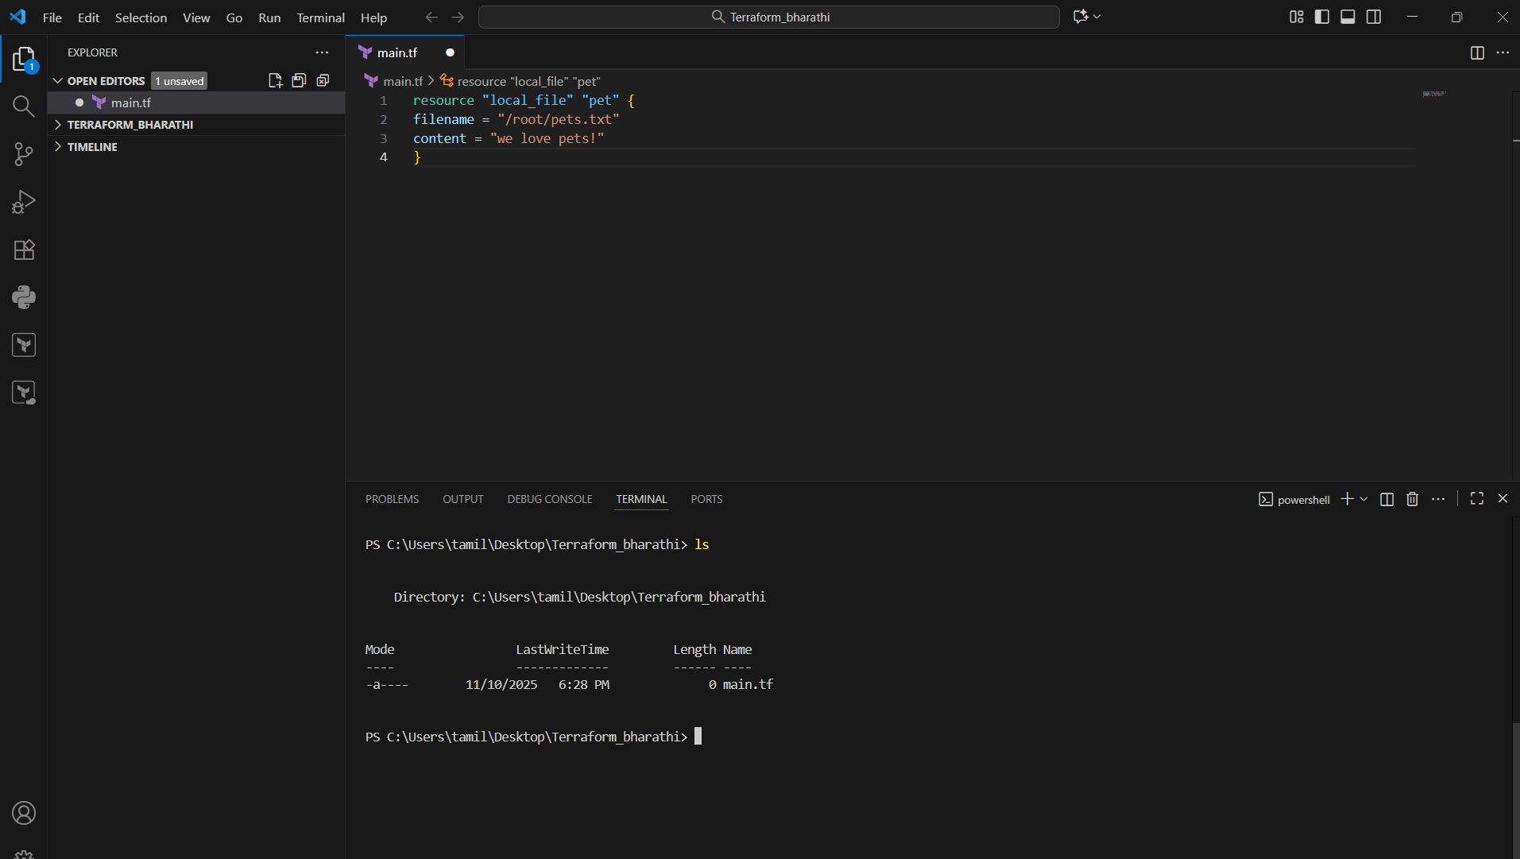

Terraform init for init
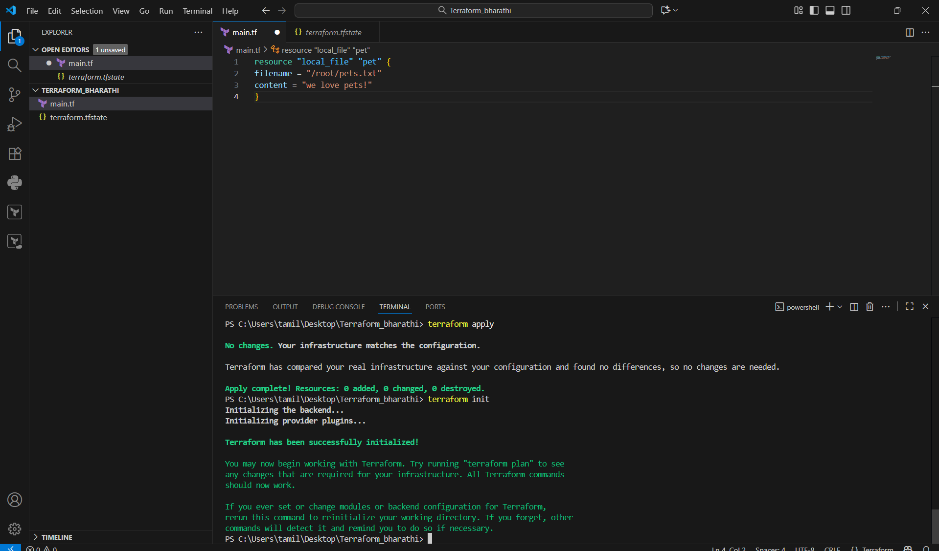
First save the execute

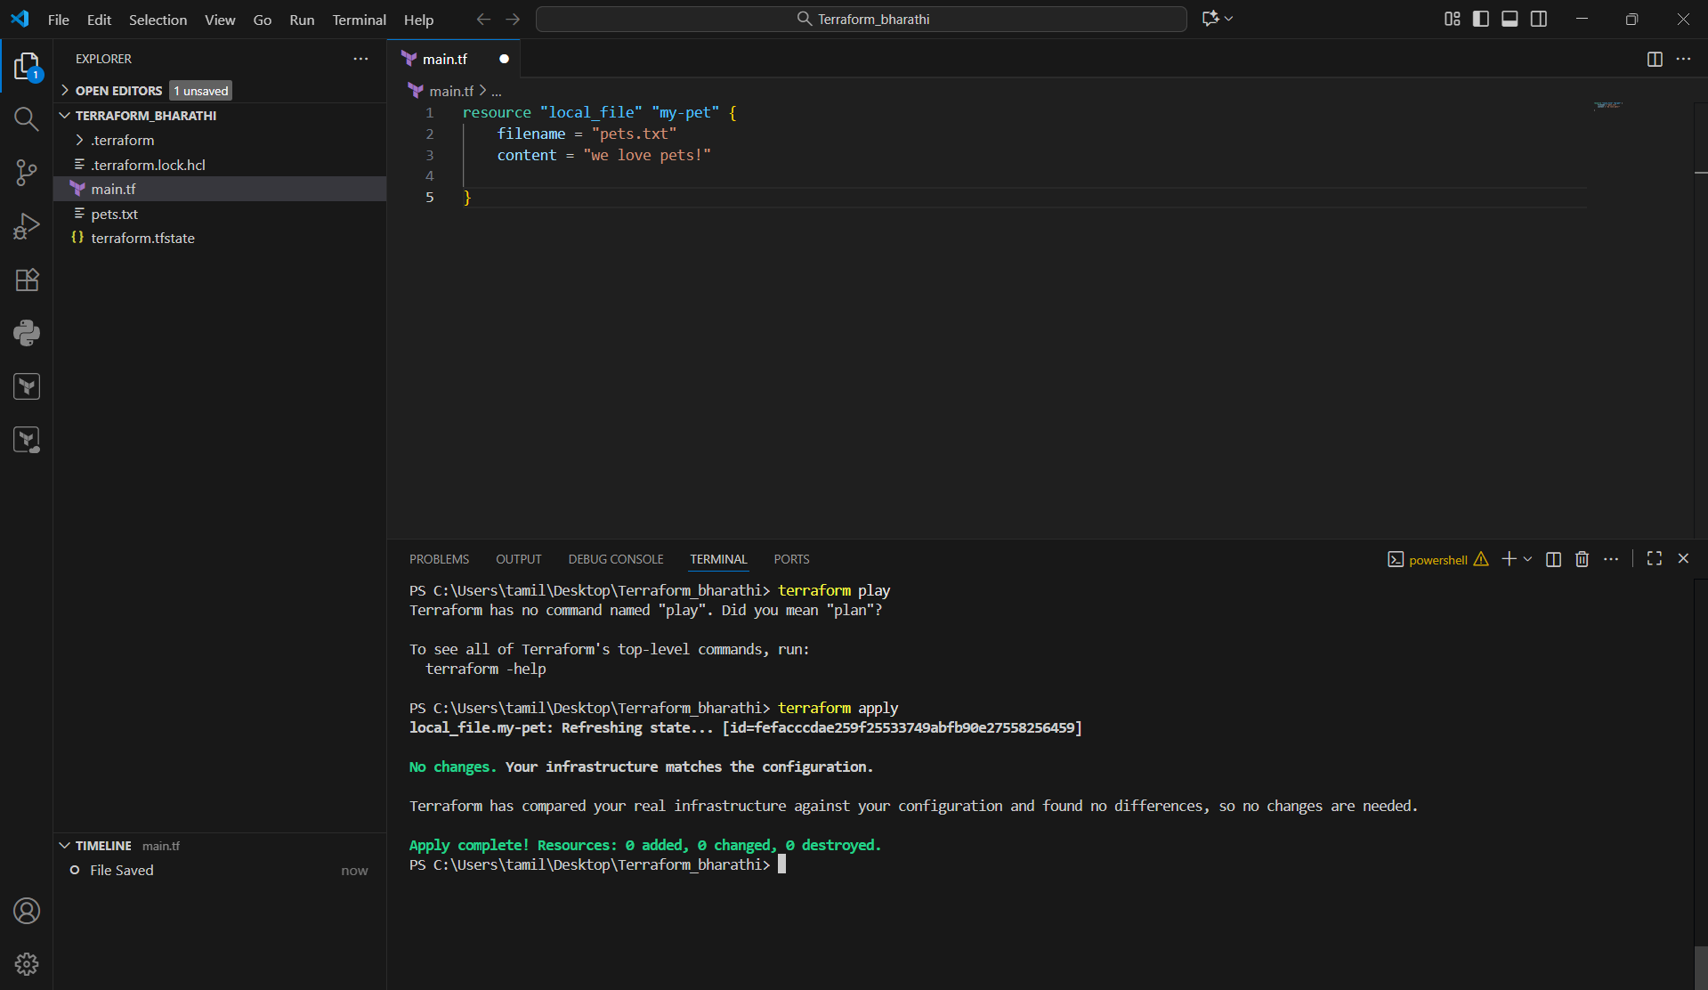
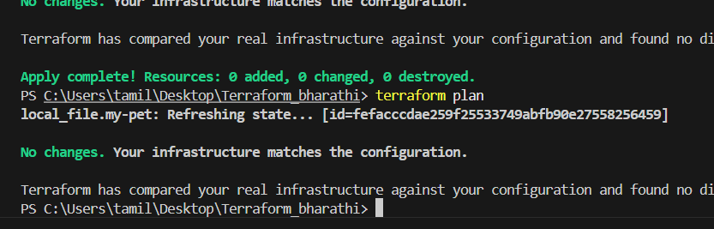

- Execute all the templates shown in the video.
- Note down below points, Terraform Init , Terraform Plan , Terraform Apply , Terraform Provider.
- Integrate a sample Terraform template in jenkins.

